Mongo DB Tutorial
Step 1:
Installation of MongoDB:
Open your favorite browser and type the below URL in the search box: https://www.mongodb.com/try/download/community

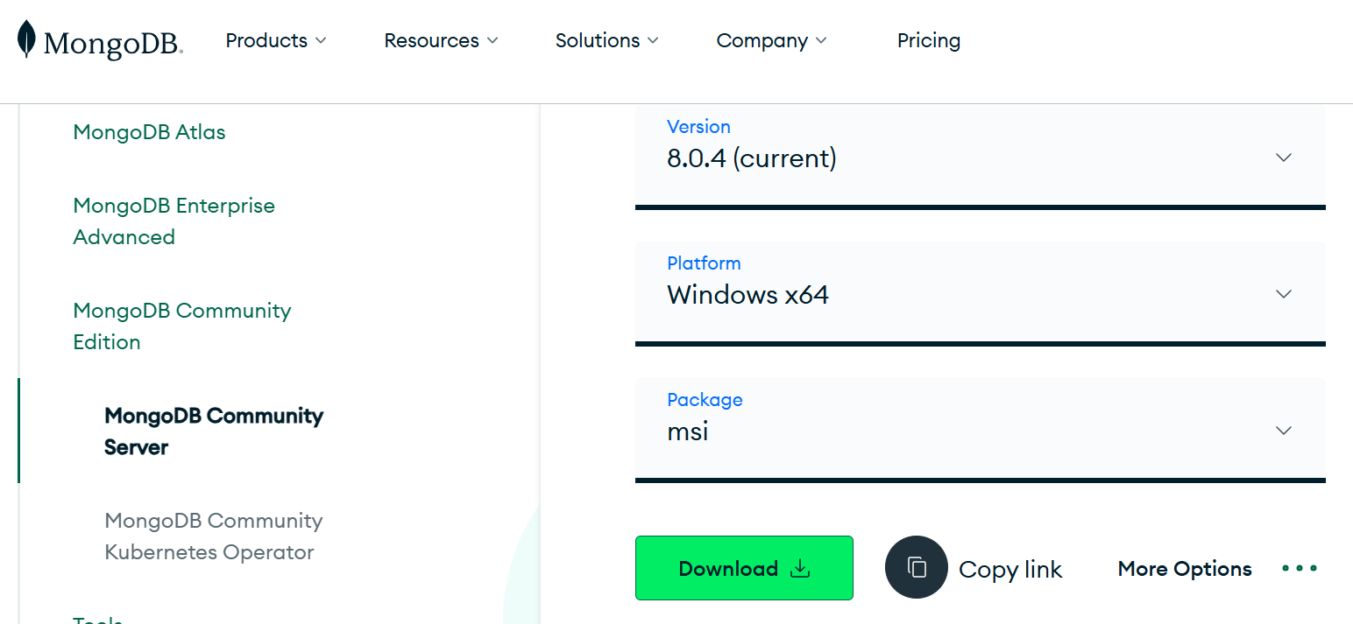

Step 2:
Click the Download button and install the MongoDB Community Server.

Step 3:
When you exeute the MongoDB, you will see the following screen after tapping the Add Connection.
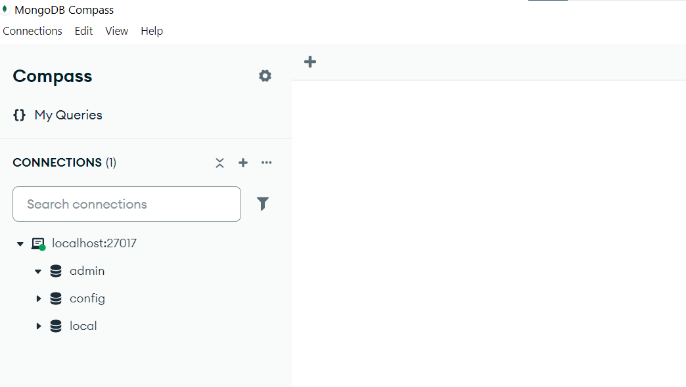

Step 4:
Creating a database in MongoDB. For CRUD operations, visit the following web site:
https://www.mongodb.com/docs/mongodb-shell/crud/#std-label-mdb-shell-crud
Keep the following points in mind:
dbms database name database
dbmsmarks table collection (of documents)
record row document

To create a database, type the following code in Notepad then copy and paste into MongoDB Compass Shell window. To open the Shell click "Admin" in the left pane and then click "Open MongoDB shell" button.

const database = 'Sales';
const collection = 'Customer';
use(database);
db.createCollection(collection);

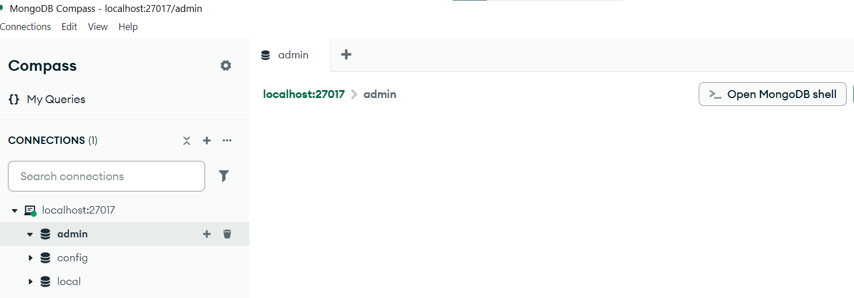

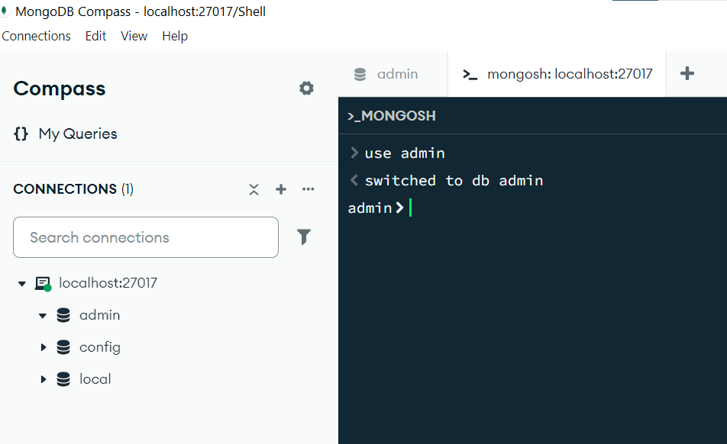

After executing the code, click the three dots in the connection and "refresh" the database.

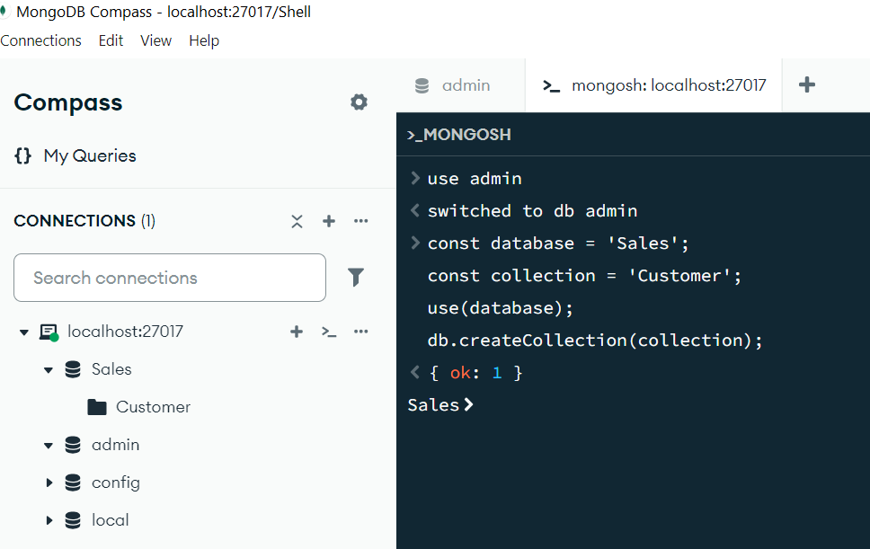

Step 5:
Now the database "Sales" and the table (i.e. collection) is ready to use.
Insertion:
# To insert one row to a collection, use the below command
>db.Customer.insertOne({"ID":"111", Name:"Supaphol"})
Next to display all documents, type the below command:
>db.Customer.find()

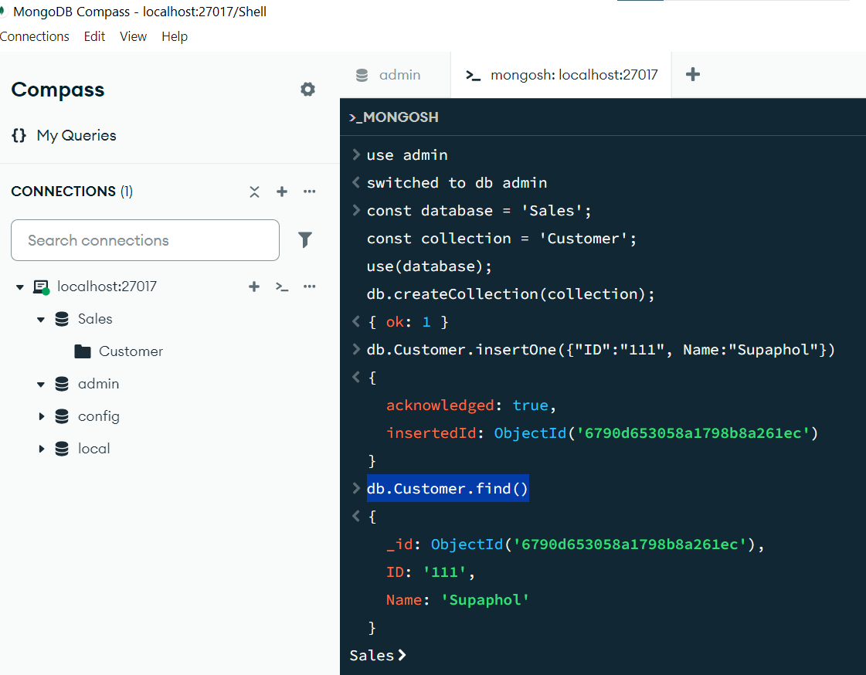

Step 6:
To insert many rows, use the following command:
db.Customer.insertMany([{"ID":"222", Name:"Niki"}, {"ID":"333", Name:"Colins", "Zipcode":51700}])
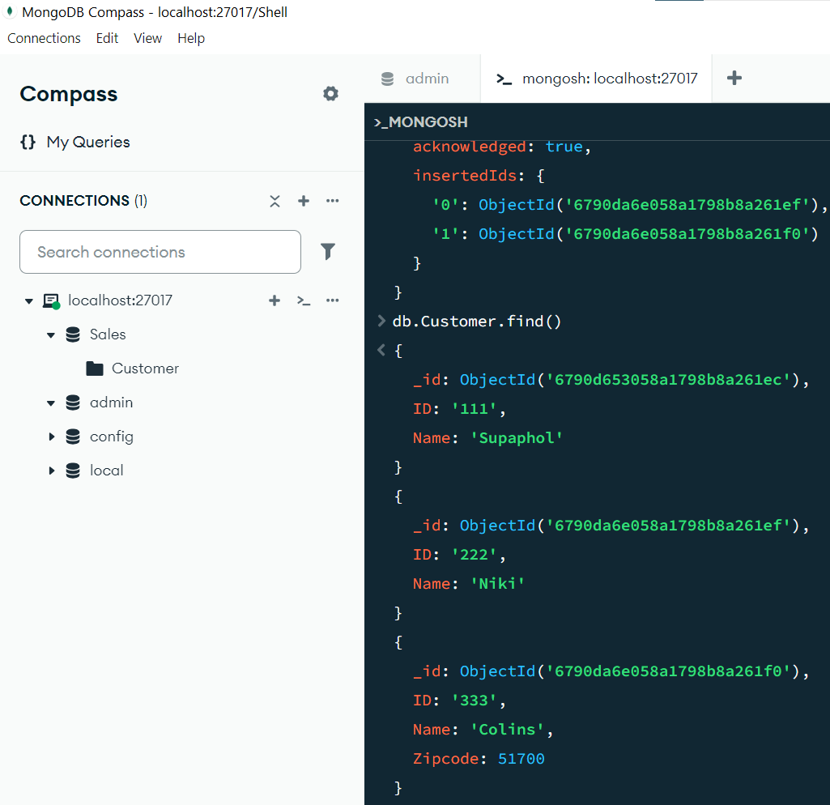
Note that the last document has an extra field "Zipcode" compared to other documents.

Step 7:
>db.Customer.find() # finds all documents in the collection
>db.dbmsmarks.find().count() # total no. of rows
>cls # clear the screen
Insert another document with the same Zipcode 51700
>db.Customer.insertOne({"ID":"444", Name:"John", Zipcode:51700})

# Find all documents where Zipcode = 51700
>db.Customer.find( { Zipcode: { $eq: 51700 } } )
Here $eq is a conditional operator. Similarly, we can use $gt, $lt, etc.

Step 8:
# update a document
>db.Customer.updateOne({Name:"Colins"},{$set:{"Zipcode":51899}})

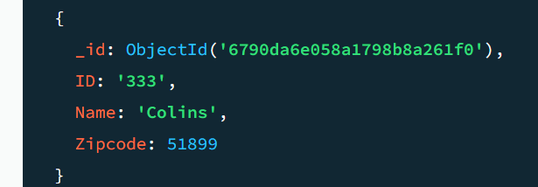

Step 9:
# delete all documents
>db.Customer.deleteMany()
# delete one document
>db.Customer.deleteOne({"ID":"111"})

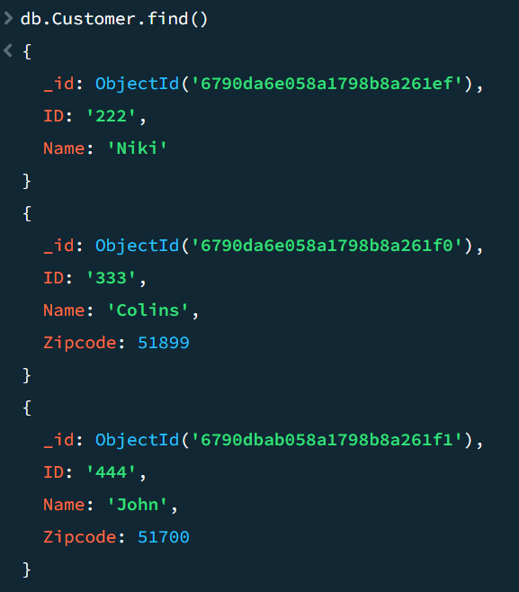

ID 111 is missing in the collection.

Step 10:
Exercise:
Import a large dataset from internet and load it into MongoDB and show some useful manipulations.

